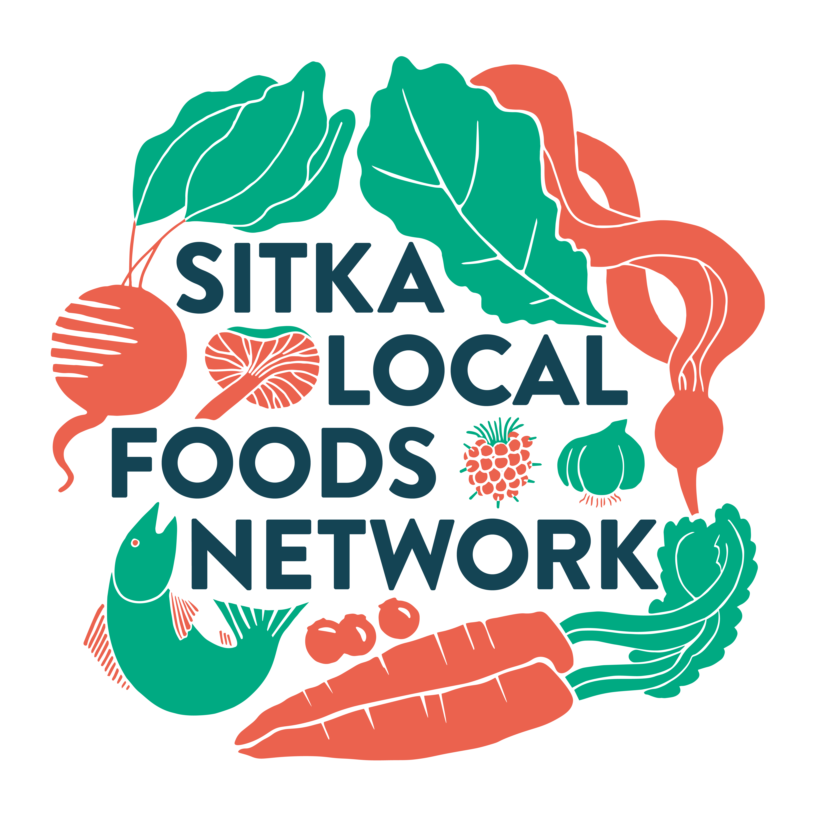

2022 SITKA FARMERS MARKET
RULES & RESPONSIBILITIES FOR VENDORS

The Sitka Farmers Market (SFM) is a project of the Sitka Local Foods Network, a nonprofit whose mission is to increase the amount of locally produced and harvested foods in the diets of Southeast Alaskans.

The Sitka Farmers Market promotes and supports local food production, including efforts to increase the availability and consumption of fresh, nutritious produce and seafood in Sitka, to support local cottage industry, and to provide an environment for the creation, and growth of positive community relationships. The primary focus of the markets is to support local food production and educate the community on the many benefits of purchasing and eating fresh, locally grown foods. The manager of the Sitka Farmers Market will do their best to provide all vendors with a safe, comfortable selling space and will actively promote the market to the public.

SUBMIT YOUR APPLICATION ONLINE
at http://sitkafarmersmarket.eventsmart.com
Sitka Local Foods Network
Attn: Sitka Farmers Market Manager
408-D Marine Street
Sitka, AK 99835
or online at sitkafarmersmarket@gmail.com
or sitkalocalfoodsnetwork@gmail.com

BEST WAYS TO COMMUNICATE WITH MARKET MANAGER

MARKET MANAGER: Nalani James
PHONE: (808) 778-9888
ASSISTANT MANAGER: Charles Bingham
PHONE: (907) 623-7660, personal, or (907) 738-7310, market phone
EMAIL: sitkafarmersmarket@gmail.com
EMAIL: sitkalocalfoodsnetwork@gmail.com
2022 SCHEDULE:

Market dates are SATURDAYS, July 2, July 16, July 30, August 13, August 27, September 10 and September 24 (every other Saturday)

II. TIME:

The markets will be open to the public on Saturdays from 10 a.m. to 1 p.m. and will start with the ringing of a bell by the Sitka Farmers Market Manager (no market sales until the bell). Setup is from 8 a.m. to 10 a.m. and takedown is from 1 p.m. to 3 p.m.

III. LOCATION: Alaska Native Brotherhood Founders Hall, 235 Katlian St., Sitka, Alaska 99835

IV. COST/ ACCOUNTABILITY DEPOSIT:

All table fees cover fees associated with running the farmers market including electricity, ANB Founders Hall rental, market manager compensation. This year all spaces for tables and food trucks are $40 per market. With Covid still making the rounds, we will need to space out the vendors. We have more space than last year, but not as much as 2019. If you preregister for all seven markets, you will receive one market free. If you pre-pay for a market and then can’t attend, you must give us at least three-day’s notice (notify by Wednesday night) to receive a partial refund, minus a $5 processing fee. If you don’t give us three-day’s notice you will forfeit your full vendor fee for the market.

In 2017, we added a children’s vendor program, where children age 14 and younger can pay $20 for the season, where they can develop their own businesses and sell food products (such as baked goods) and arts and crafts they make themselves. Parental supervision is encouraged, and child vendors should follow the same rules as adult vendors.

We still want to promote locally grown and produced food, but we feel making the market more attractive to all types of vendors will help make it more profitable for local growers and food-producers to have booths at the market.

The Sitka Local Foods Network will host a Sitka Farmers Market vendor meeting from 6:30-8 p.m. on a date and at a location TBA (this meeting will be announced on our website and on Facebook and Twitter). At this meeting we will discuss the market rules and responsibilities. We also will have someone at the meeting to discuss food safety regulations. Past and prospective vendors are encouraged to attend.

We are returning to ANB Founders Hall, where we held our first 12 years of markets. ANB has tables and chairs to use for the inside vendors, which will be set up in two circles (an outer loop and an inner loop). Outside vendors will need to bring their own tables and chairs, and maybe a 10x10 market tent.

Fees are used to cover the cost of renting the venue, and other expenses. See registration form below for payment/set-up fee and deposit instructions.

This year we are eliminating the accountability deposit from past years ($50). But vendors still need to be responsible for their areas and keep it clean, including cleaning up at the end of the market. If a vendor violates market rules about cleaning or behavior, there is a $50 fine (plus the loss of all pre-paid vendor fees) before the vendor will be allowed to participate in future markets.

V. VENDOR REGISTRATION:

All eligible vendors will register and pay vendor fees using our new online vendor registration page, http://sitkafarmersmarket.eventsmart.com. They also must read this document and sign and return the Vendor’s Registration Form (last page) before their first marketed of the season. By their signature they indicate they have read and agree to abide by the Market Rules and Responsibilities.

VI. ACCEPTED VENDOR SALES ACTIVITIES:

For the purposes of these Rules & Policies, “local” means harvested, processed or made within the state of Alaska. All products offered for sale at the Sitka Farmers Market shall be subject to inspection and approval by the market manager/assistant manager. If any items are deemed not in compliance with these rules and policies (for example, not to have been grown or produced as stated by the vendor), the vendor will be asked to remove such items. Vendors must comply with such requests or be asked to immediately leave the market.

VII. SPACE ASSIGNMENT:

Space for the markets is assigned by the market manager, who will attempt to place you in or as near as possible to the space you request. Register early to have the first choice of location. In order to fulfill the goals of the Sitka Farmers Market, and because of limited space this year, vendor spaces will be assigned based on a priority system in the order that follows below:

- Fresh Farm Products and Fish: Vendors offering locally grown or harvested foods will be given first tier priority for available space. Includes locally grown fresh fruits and vegetables, nuts, herbs, honey, dairy, meats, and eggs. Also included in this category are fresh flowers, nursery stock, and plants. All fresh farm products must be grown or produced locally by the vendor. This category also includes locally harvested fish.

2. Value-Added Farm and Processed Foods: Includes seafood, bread, preserves, jams and jellies, cider, syrups, vinegars, salsas, dried fruit, teas, flours, salad dressings, and dairy products. All value-added farm foods must be made using a majority of products/ingredients (over 50%) grown or produced locally by the vendor. Vendors in this category must have personally cooked, canned, baked or otherwise produced the product/s they sell. All value-added farm and processed foods must have the proper labeling, permits and licensing as required by Alaska Department of Environment Conservation and Alaska State Health Food Code. Alaska DEC requires recipes/processes on hand for many home-based food items. You can find Alaska food safety and sanitation regulations at http://dec.alaska.gov/eh/fss.aspx

3. Prepared Food: Freshly made foods, available for sale and consumption on-site. Prepared food vendors are responsible for determining what permits and licenses are required for their products and copies of all relevant permits and licenses must be submitted to the market manager along with vendor application, prior to selling at the market. Prepared food vendors must also have required permits and licenses (or copies) with them at every market. Prepared food vendors should use ingredients produced in the state of Alaska as much as possible. SLFN gives preference to those prepared food vendors using local ingredients and who provide a good variety of healthy foods.

4. Local Art and Crafts: Vendors of locally produced arts, crafts, wild-crafted products and prepared foods shall have second tier priority for available space. All art/crafts must be made or produced locally by the vendor selling them. Crafts should be made of components produced or gathered locally as much as possible. Personal collections, second-hand items, and items manufactured outside of Alaska WILL NOT be allowed for sale, anyone attempting to sell such items will be asked to leave the market for the duration of the market season.

5. Non-Profit and Community Groups: Local non-profits and community groups are encouraged to set up informational and educational displays at the farmers market, or to have fundraisers such as selling raffle tickets or baked goods. Any group desiring to do this shall contact the market manager in advance to arrange for a space. No one is allowed to solicit shoppers outside their table area or to ‘button-hole’ market customers — all vendors must remain at their table when selling and/or promoting their cause. No political activity, such as campaigning or petition signature-gathering, is allowed at the markets.

VIII. VENDOR HEALTH PRACTICES:

- All Vendors must adhere to sanitary procedures as outlined by the State of Alaska Health Department, DEC and Food Safety Regulations. Call the DEC Food Safety office in Sitka 747-8614 (Alex Carlson is the new DEC food safety officer in Sitka) to see if you need to update your permits and licenses today.

- All vendors are asked to remove any trash and waste that accumulates from their booth displays. Your cooperation is greatly appreciated. There will be no storage at ANB Founders Hall.

- The indoor part of the venue will feature two circles of tables inside ANB Founders Hall, with chairs for the vendor. Outdoor vendors (food trucks, etc.) will need to provide their own tables and chairs, and maybe a 10x10 market tent.

- All vendors selling processed and value-added foods are responsible for obtaining all proper Health Department licenses, Food Handlers permits and meeting any AK DEC requirements prior to selling at the market. For food related permits, call the DEC Food Safety office in Sitka 747-8614. This office is very helpful and is working to help us ensure that all food served and sold at the Sitka Farmers Market is safe to eat.

- All processed food items MUST be prepared in a licensed commercial kitchen, unless they qualify as cottage foods. The kitchen at ANB Hall is a licensed commercial kitchen operated by the Alaska Native Sisterhood. Please contact the ANS Camp No. 4 for fees and the approval process to use the kitchen. Unless you make arrangements with ANS and pay ANS’s fees, you will not have access to the ANS kitchen. For those preparing food in another commercial kitchen, the location of that kitchen shall be disclosed to the market manager on request. An incomplete list of other commercial kitchens in Sitka can be found below.

- All vendors offering prepared food or food samples MUST adhere to State of Alaska DEC food safety regulations, which include providing your own hand-washing station at your booth. A hand-washing station includes a Jerry can of warm water, a catch bucket, soap and paper towels. For information, call the DEC Food Safety office in Sitka 747-8614.

IX. CITY SALES TAX: The SLFN does not collect sales tax for vendors. If you need assistance filing your own taxes, please contact the City Sales Tax Clerk.

Vendors participating in more than one market per year are responsible for collection of City Sales Tax. To register with the city, contact the city sales tax clerk, at 747-1840. All of the necessary forms are also available online at the city’s website. The tax clerk will be able to assist you.

X. PRODUCTS and SALES:

- Please DO NOT display or attempt to sell goods produced outside of Alaska. There have been reports of vendors breaking this rule in the past. PLEASE DO NOT DO IT. The only exceptions are prepared foods for consumption at the market. Please ask the Market Manager if you are unsure. Imported handicrafts, for example, are not appropriate for these markets and will not be allowed. All food for sale that is not produced in Alaska or has value added in Sitka, needs to be consumed at the market.

- Products, services, or informational displays considered to be inappropriate may be prohibited, first at the discretion of the Sitka Farmers Market Manager, and ultimately by the Sitka Local Foods Network Board of Directors.

- Each vendor sets his/her own prices and is responsible for all aspects of display, sales and cash flow, and collection of city sales tax. Please note that any items sold by weight must be weighed using a State of Alaska certified scale. In many cases, it’s easier to sell by the item, such as selling a bunch of carrots instead of two pounds of carrots.

- Please do not begin sales to the public until after the market bell is rung to signal opening of the market. The EXCEPTION is that vendors may sell early to each other and beverages (coffee & tea) may be sold before 10am market bell.

- Items sold that are considered “cosmetic or drug” related are required to comply with Federal Food and Drug Administration rules. Also, no alcohol or marijuana/edible sales.
- Please bring enough product to last the entire length of the market. We realize this may not always be possible, but we would greatly appreciate you complying with this expectation to the best of your ability. We will move you to the back of the market area if you continue to sell out and pack up early. This way folks arriving later aren’t greeted with empty tables.
- In previous years, the Sitka Local Foods Network sold tokens that people without cash/checks could buy to spend at vendor booths. This was because we used to be the only vendor able to take credit cards. Now that more people have Square, Venmo, and other apps, we no longer will be using the tokens. Also, it meant we were the ones having to pay the handling fees. Vendors who want to accept charges will need to get a Square app to accept their own charges.

XI. ANS HALL KITCHEN USE and PREPARED FOOD SALES:
(*except home bakers – see HOME BAKERS)
- The ANS Hall kitchen is certified as a commercial kitchen for use by those preparing and selling food. There is limited space in the kitchen, so if you need to use the ANS kitchen, please contact the Alaska Native Sisterhood directly. Since we are using ANB Founders Hall this year as our market venue, people can still book this kitchen to prepare foods to sell during the market but they need to pay ANS kitchen rental and a Sitka Farmers Market vendor fee. If you wish to sell prepared foods that aren’t qualified cottage foods, you MUST use a certified commercial kitchen and you MUST have a food handler permit. For information or a permit, contact the Department of Environmental Conservation, Sitka – Food Safety & Sanitation at 747-8614

B. Certified Commercial Kitchens in Sitka include (incomplete list):

1) Sitka Lutheran Church/Sitka Kitch – 224 Lincoln Street – 747-3338
2) St. Peter’s by the Sea Episcopal Church – 611 Lincoln Street – 747-3977
3) Sweetland Hall on the Sitka Fine Arts Camp – Lincoln Street – 747-3085
4) Swan Lake Senior Center – 402 Lake Street – 747-8617
5) Harrigan Centennial Hall – 330 Harbor Drive – 747-4090
6) Sitka Tribal Enterprises Cottage Industry Development Center – 4608 Halibut Point Road – 747-7290 (new)

C. HOME BAKERS – The Sitka Farmers Market now has a permit to allow home bakers to sell their goods at the market. However, you must follow certain guidelines. Cottage food rules no longer require that all goods are baked within 24 hours of market, but all ingredients must be clearly labeled (with a list of possible allergens, such as peanuts) and the baked goods should be fresh. Home bakers also are required to obtain a food handler permit from the State of Alaska. This is fast and easy and costs just $10. Go to this website to obtain your Alaska State food handlers permit: http://dec.alaska.gov/eh/fss/food-worker-card. For more information on how to obtain your food handler’s card, call the DEC Food Safety office in Sitka 747-8614.

XII. VENDOR SET UP RESPONSIBILITY:

- Arrive on time. All vendors MUST arrive at least one-half-hour before market opens (no later than 9:30 AM). Any vendor with an assigned space who is not present at least one half-hour before market opens must be prepared to forfeit their space to another vendor for the day. We are able to start setting up at 8am (two hours before opening). A bell will ring at 10am to indicate when selling may begin. ALL vendors are expected to remain until closing. All vendors must be set up and ready to sell when the market opens at 10am. If vendors do not arrive by 9:45am to set up their booths, they will receive a warning. On the second time being tardy, they will be charged a fee of $25.

B. Communicate changes to Market Manager. Any vendor NOT PLANNING to attend the market must notify the market manager at least one (1) week in advance. Contact the market manager, Nalani James, at (808) 778-9888 or sitkafarmersmarket@gmail.com. Note: This year, we ask all vendors to use our new online registration website, http://sitkafarmersmarket.eventsmart.com, to register and prepay for their market spaces. If you are a “no show” without giving us notice, the full cost of the table will be taken out of your registration fee. A partial refund ($35 instead of $40) if you contact the market manager at least three days in advance (by Wednesday night). Please understand the importance of having a market full of vendors for the ongoing success of this endeavor.

C. No Sales Before the Bell! Vendors may not sell any product until the official opening of the market, as indicated by the bell. Any vendor found selling before the bell to any customers (other than vendors) will be given one market warning and if asked again will be asked to leave the market for the duration of the season. Any EXCEPTION to this rule may be used at the discretion of the market manager.

D. Secure Your Tent: All vendors are required to supply their own tent this year including providing their own set up and breakdown each market day. Tents WILL NOT be rented or supplied to vendors. All vendors with tents and umbrellas at the Sitka Farmers Market during regular market hours, including setup and breakdown period, are required to have their canopies sufficiently and safely anchored to the ground from the time their canopy is put up to the time it is taken down. Any vendor who fails to properly anchor their canopy or umbrella will not be allowed to sell at the market that day unless the vendor chooses to take down and stow their canopy and sell without it. “Sufficiently and Safely Anchored” means that each canopy leg must have no less than 24 lbs (pounds) anchoring each leg, securely and safely attached so that it does not impose a hazard to the customer. This language is taken directly from the Alaska State Farmers Market Association Guidelines. We are required, as a member market, to agree to enforce this language. Any damage caused by a vendor due to insufficiently secured tent/umbrella will be the liability of the vendor.

E. Vendor Parking: All vehicles must be unloaded and removed from the market area and the ANB Founders Hall/BIHA parking lots no later than 20 minutes prior (9:40am) to the market opening. Vendors who use vehicles as part of their display (this includes food trucks) must be assigned to designated “Vendor Vehicle Spots” and remain there until the market closes. If possible, please park your vehicle away from the ANB Founders Hall to allow space for customer parking (many vendors briefly park in front of the building to unload their products, then go find another parking spot). The EXCEPTION to this rule are vendors and SLFN Board Members and market staff who have been requested to park their cars at the back of the parking lot to provide a wind shield during high gale wind market days. Any parking exceptions must be approved by the market manager prior to the start of each market.

XIII. VENDOR CLEAN UP RESPONSIBILITY:

- Booth Breakdown: All vendors have one hour (until 2pm) to break down their booths and vacate the premises due to our ANB Founders Hall Rental Agreement.

B. Clean-up Stall Area
Vendors are responsible for cleaning up their sales area prior to leaving the market. All containers, signs, coolers, plants, bags, trash, etc., must be removed at the end of the market. Market trashcans are for customers’ use only. Vendors offering prepared food for consumption at the market must provide their own garbage can and remove it at the end of the day. Vendors are responsible for cleaning and sweeping their booth area, and for leaving the parking lot free of grease, food and miscellaneous debris. Vendors will have one hour to clean up and remove all of their belongings after close of market. Vendors who remain longer than one hour will be charged any additional rental fees or late vacating penalties charged to the market (currently $20/hour). Vendors who do not properly clean up their stall area will not receive their cleaning deposit back. Please check out with market manager to ensure stall area is properly cleaned and undamaged. There is no storage of vendor or market supplies at Harrigan Centennial Hall. You must take your supplies home between markets.

XIV. MARKET-WIDE POLICIES:

A. Drugs, Alcohol and Firearms: Vendors nor Customers may not use, sell, be under the influence of, or in possession of controlled substances including medical marijuana and/or unauthorized alcoholic beverages during Market hours at ANB Founders Hall or in the Baranof Island Housing Authority parking lot. Neither vendors nor customers may be in possession of firearms or weapons while participating in the Sitka Farmers Market.

B. Animals in the Market: No pets are allowed in the market area during market hours due to Alaska State Food Safety Rules & Regulations. Anyone out of compliance with this rule will be kindly asked to leave the market. The only exceptions to this policy are service animals, including trained aid dogs. Previously approved and scheduled demonstrations involving animals may be allowed.

C. No Smoking! Smoking is prohibited at Sitka Farmers Market during market hours, including by our outdoors booths. Signage will be displayed throughout the market to discourage misconduct of this rule.

D. COVID-19 Protocols: Even though more people are getting vaccinated and restrictions are easing, we still have some COVID-19 making the rounds in Alaska. We encourage all vendors and customers to wear masks and use hand sanitizer, and indoor vendors will be required to wear masks if Sitka is at Medium or High risk levels. If you are feeling sick, please stay home. We don’t want to spread the coronavirus to anybody. We also ask people to not bunch up and to give other people about six feet of space.

E. Human Relations. Vendors will conduct themselves courteously to the market manager, other vendors, and customers. Vendors may not attempt to cheat or mislead customers. In order to keep market tables open to shoppers, vendors are reminded not to congregate in front of booths for conversation with friends and other vendors. Discourteous behavior to anyone at the market may result in disciplinary action including suspension of vendor privileges.

F. Grievances. All vendors may appeal to the market manager for help in solving a problem with customers, other vendors or the public. Vendors shall accept the market manager’s decisions in the event of such disputes. Vendors with a concern about market policies and/or procedures should first approach the market manager for resolution. The market manager is responsible for contacting the local authorities if disputes become unmanageable. If the manager cannot settle the dispute to the vendor’s satisfaction, the Vendor may appeal to the Sitka Local Foods Network Market Board Liaison, Amanda Anjum, who may be reached at
sitkalocalfoodsnetwork@gmail.com.

XV. HARRIGAN CENTENNIAL HALL RULES:

NO alcohol is allowed on the premises
NO smoking in the market area
NO use of the Alaska Native Sisterhood Kitchen is allowed without a signed contract from ANS.
NO open cooking fires under the building overhang. Open cooking fires must be at least 10 feet away from the building (in the outdoor vendor space)
NO dogs or other animals are allowed inside the market area, except permitted service animals.
NO leftover food should remain in the market area. Take it with you.
CLEAN UP your own space after use of the market area. Garbage cans and recycling bins will be provided at several locations. Please cut down and flatten cardboard boxes. There is no vendor or market storage at ANB Founders Hall during the market season. You must take all market supplies home between markets.
PLEASE keep your children in view and under your control

Vendor Registration Form 2022

Name:_________________________ Email:___________________
Business Name:__________________
Business Address Line 1:________________ Phone:_______________
Business Address Line 2:________________

Vendor Category (circle one)

Local produce Local value-added Prepared food Non-food Nonprofit/community

Table (please circle one)

FULL ($40/market) CHILDREN’S ($20/season)

Market Dates (please circle all markets you plan to participate in)

7/2 7/16 7/30 8/13 8/27 9/10 9/24

Multiply your tables by the number of markets you plan to attend. This is your registration cost.

For example, a vendor with a full table attending all seven markets pays a $240 registration cost (the price of six markets). A vendor participating in three markets pays $120.

Please write your total registration cost here:_________

Signature:_________________________ Date:__________

Please register and pay using the http://sitkafarmersmarket.eventsmart.com online registration page.
If you need help, contact Charles Bingham at (907) 623-7660:

Sitka Local Foods Network (make your checks out to SITKA LOCAL FOODS NETWORK)
ATTN: Sitka Farmers Market
408 D Marine St
Sitka, AK 99835

